20.60: a)
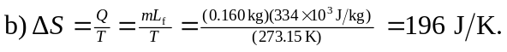
- From the time equilbrium has been reached, there is no heat exchange between the rod and its surroundings (as much heat leaves the end of the rod in the ice as enters at the end of the rod in the boiling water), so the entropy change of the copper rod is zero. d) 